**Creating First Script using Selenium:**

https://seleniumhq.github.io/selenium/docs/api/java/index.html

Go to the above url and click on WebDriver link and it shows all the methods.

WebDriver is an interface.

The different classes that implemented the above interface are

ChromeDriver, EdgeDriver, FirefoxDriver, InternetExplorerDriver, OperaDriver

ChromeDriver class is used to run tests on chrome browser.

EdgeDriver class is used to run tests on Microsoft Edge.

FirefoxDriver is used to run tests on Firefox browser.

InternetExplorerDriver is used to run tests on Internet Explorer.

OperaDriver is used to run tests on Opera Browser.

First, we need to create an object of the above classes to test any application on any browser.

For executing scripts on Chrome Browser:

WebDriver driver = new ChromeDriver();

Microsoft Edge:

WebDriver driver = new EdgeDriver();

Firefox Browser:

WebDriver driver = new FirefoxDriver();

Internet Explorer:

WebDriver driver = new InternetExplorerDriver();

Opera Explorer:

WebDriver driver = new OperaDriver();

**Example:**

**package** Selenium;

**import** org.openqa.selenium.WebDriver;

**import** org.openqa.selenium.chrome.ChromeDriver;

//import org.openqa.selenium.firefox.FirefoxDriver;

//import org.openqa.selenium.ie.InternetExplorerDriver;

**public** **class** FirstScript {

**public** **static** **void** main(String[] args) {

WebDriver driver = **new** ChromeDriver();

//WebDriver driver = new FirefoxDriver();

//WebDriver driver = new InternetExplorerDriver();

}

}

**Web Drivers for executing the scripts:**

Even though we have created the above objects we can’t directly access the browsers because they belong to different vendors.

We need to download third party browser drivers and mention the paths in the script to access the browsers.

Go to the following url

<https://www.seleniumhq.org/download/>

Go to third party browser drivers section and download chrome driver and unzip it.

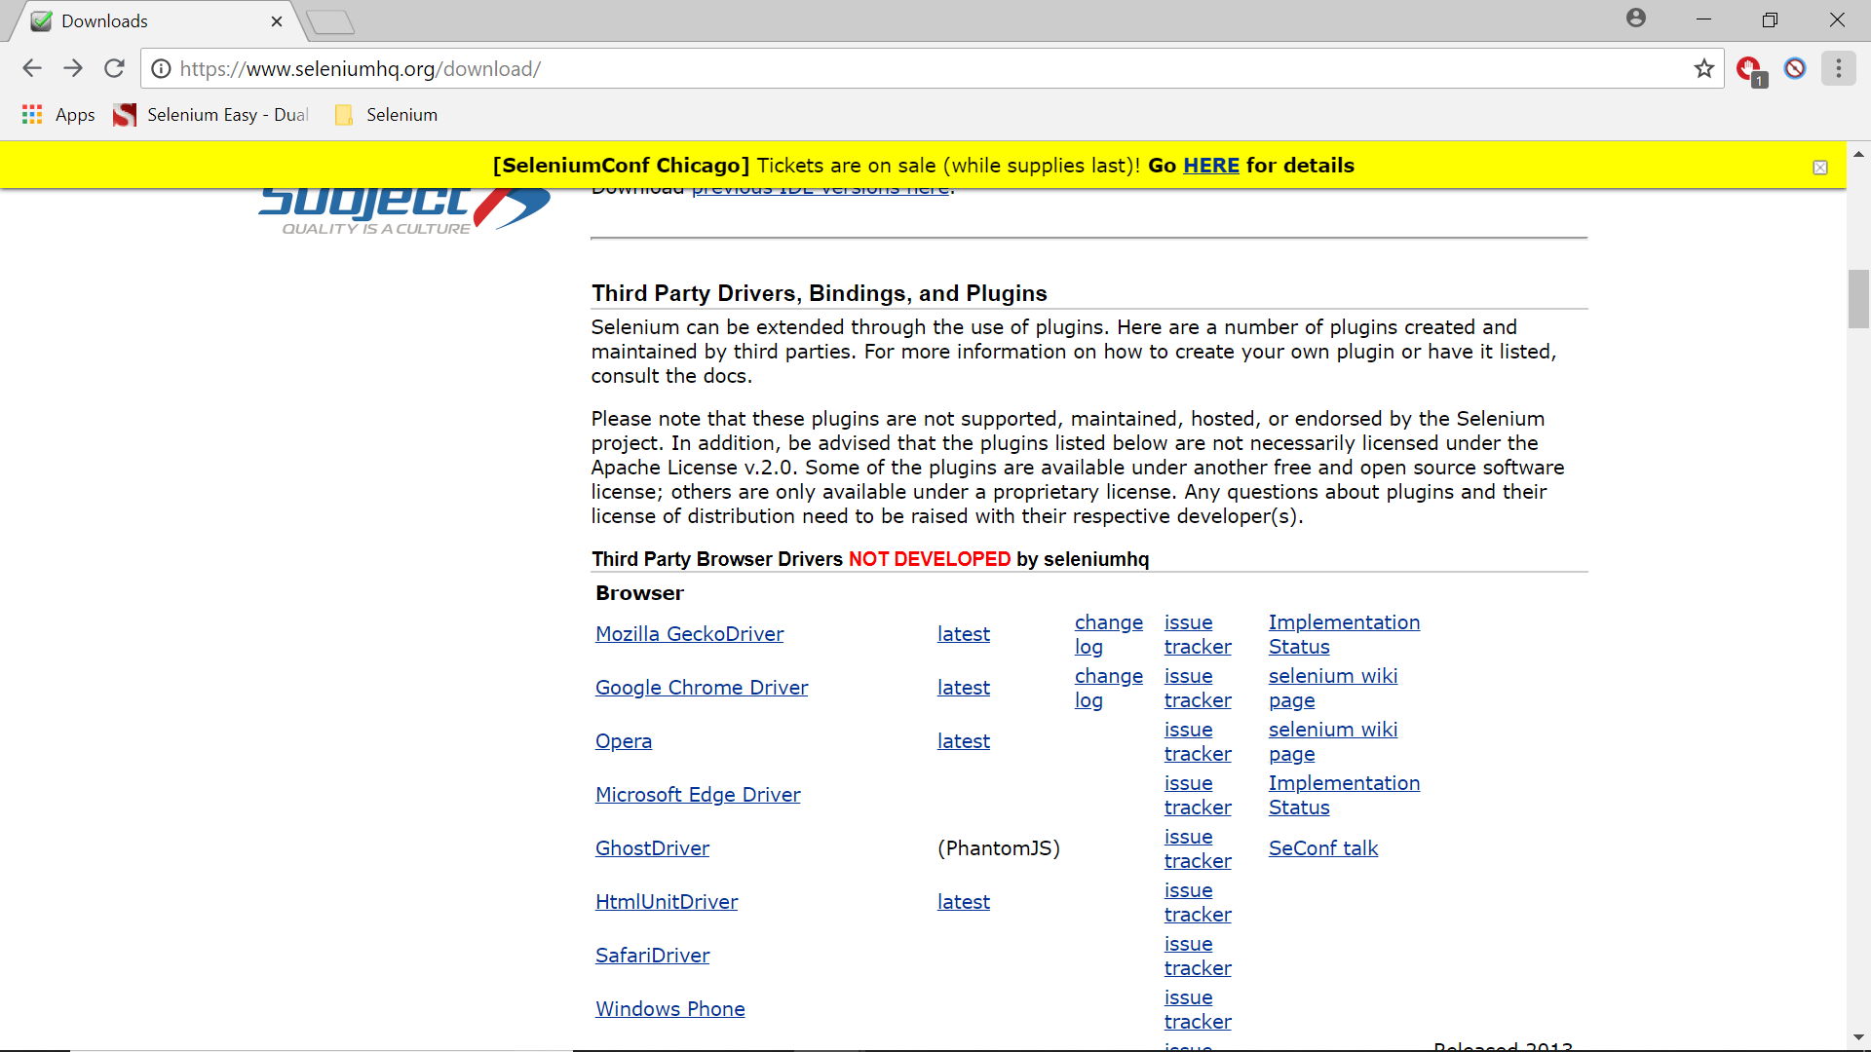

Note: Only Chrome Driver can be downloaded from the above page. Download other drivers searching google.

Note: If any of the drivers are not working download the older versions.

Chrome Driver:

https://chromedriver.storage.googleapis.com/index.html

Once you download the driver you need to set a System Property with these paths in the script.

The system properties you have to set up are:

Chrome Driver:

System.setProperty(“webdriver.chrome.driver”,”Path to chrome driver”);

**Example:**

**package** Selenium;

**import** org.openqa.selenium.WebDriver;

**import** org.openqa.selenium.chrome.ChromeDriver;

**public** **class** ChromeBrowser {

**public** **static** **void** main(String[] args) {

System.*setProperty*("webdriver.chrome.driver", "C:\\BrowserDrivers\\chromedriver.exe");

WebDriver driver = **new** ChromeDriver();

driver.get("http://www.rediff.com");

}

}

The above will open the chrome browser and open the site rediff.com